
2025 Third Quarter Letter
Just a Normal Year

I imagine the term “normal” would probably not be the first word that you’d be inclined to use when describing the stock market activity so far in 2025. However, as of the end of the third quarter, in most respects, that is exactly what we’ve gotten. Both from a performance and believe or not, a volatility perspective.

The current S&P 500 return is in line with the long-term historical averages of 10-12%. But surely 2025 must be well above average in terms of volatility? In fact, despite the dramatic April tariff sell-off and subsequent historic rebound, there have only been 22 trading days with moves exceeding 1% in 2025, on pace to finish well below the historical average of 59 days. Why then has it felt so much more volatile?
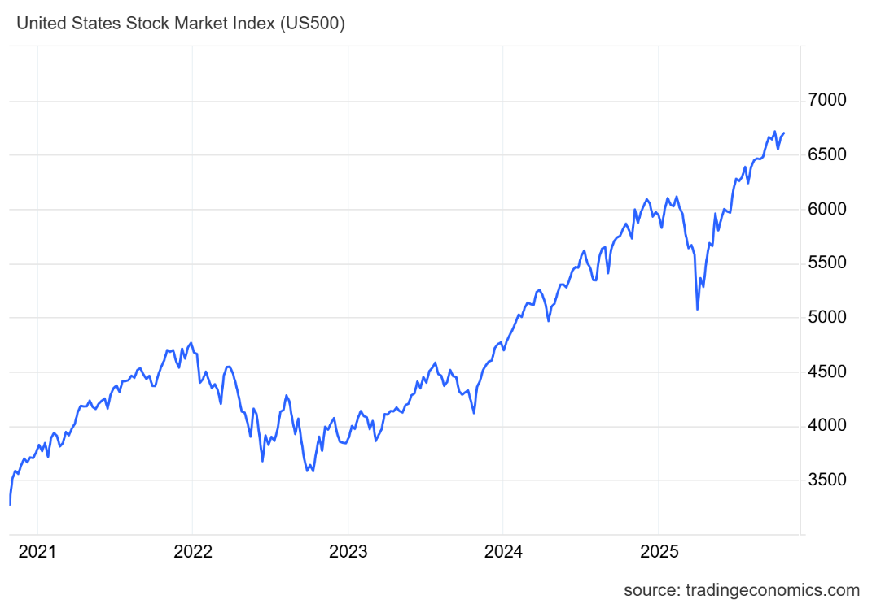
A big factor has been the methodology that the Administration employed to achieve their desired reorientation of global trade. The “Liberation Day” tariff rates caught the financial markets (and foreign leaders) off guard and raised a lot of short-term uncertainty. However, as the July 9 deadline for imposing higher tariffs approached, nearly all the US major trading partners reached agreements on tariffs that were well below those that were initially proposed.

Economic trends

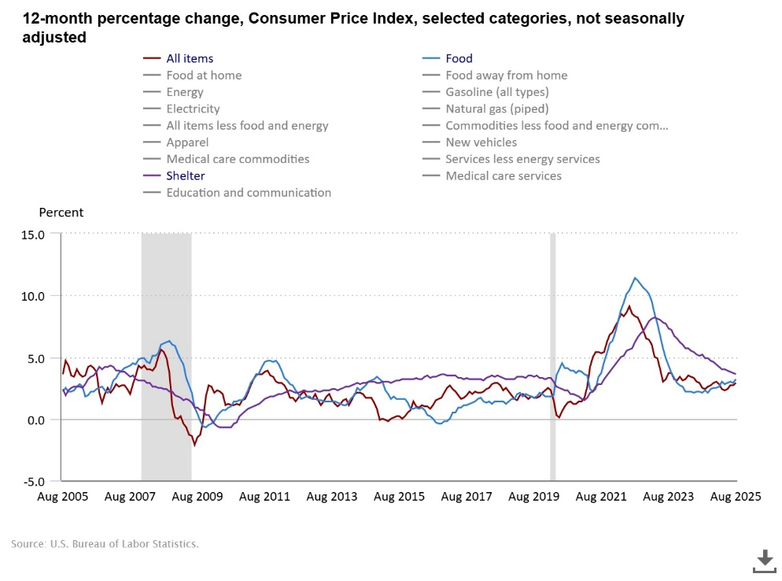
The bright spot has been the amazing ability of US companies to adapt and persist through this period of uncertainty. Earnings estimates coming into the quarter were modest at roughly 4% earnings per share growth, as many companies had pulled their guidance during first quarter earnings calls due to the lack of visibility on tariffs. However, with over 90 percent of the S&P 500 having reported the actual EPS growth rate is just under 12%, substantially exceeding expectations. And many more companies felt comfortable providing guidance for the rest of the year, with nearly 60% of those increasing their outlook.

While 82% of S&P 500 companies exceeded their expectations, the technology and communications services, and other AI-adjacent companies continued to drive the bulk of the earnings growth. Capital spending plans from the mega-cap once again exceeded expectations, as the buildout of data centers required to support the AI Revolution appears to still be in its early stages.

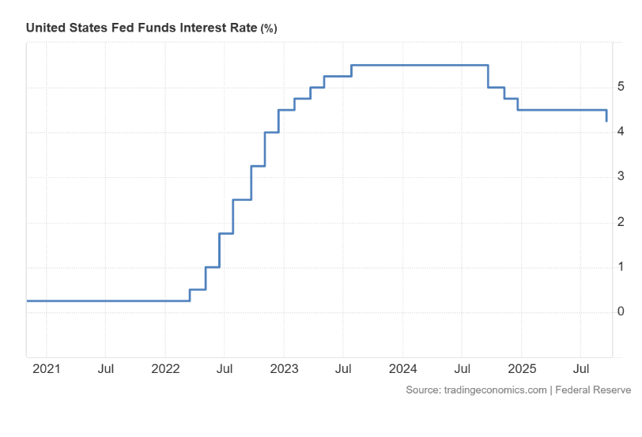
Interest rates have broken out their 4.25-4.75% range to settle just above 4% as the bond market cheers the resumption of the Fed rate cut cycle which, until recently, had been on pause all year waiting for the tariff and inflation outlook to crystallize. It turns out the final necessary nudge came the increasingly soft job market data, while the inflation outlook remains a tad murky.

Heading Down the Homestretch

As we head into fall, the big question is will things continue to be “normal”? And what exactly would a normal market look like through year end?

The rally from April lows in the S&P ranks among the biggest 100-day rallies in stock market history. Therefore, as we move into the remainder of the year, we remain as diligent as ever with our positioning and strategies. Given the large number of big institutional investors who have been underweight stocks, and have watched this rally with skepticism, we expect any market decline to be short-lived. Valuations are currently on the lofty side, but with the Fed cutting rates that alone likely isn’t enough to derail the rally during the seasonally strong holiday quarter.
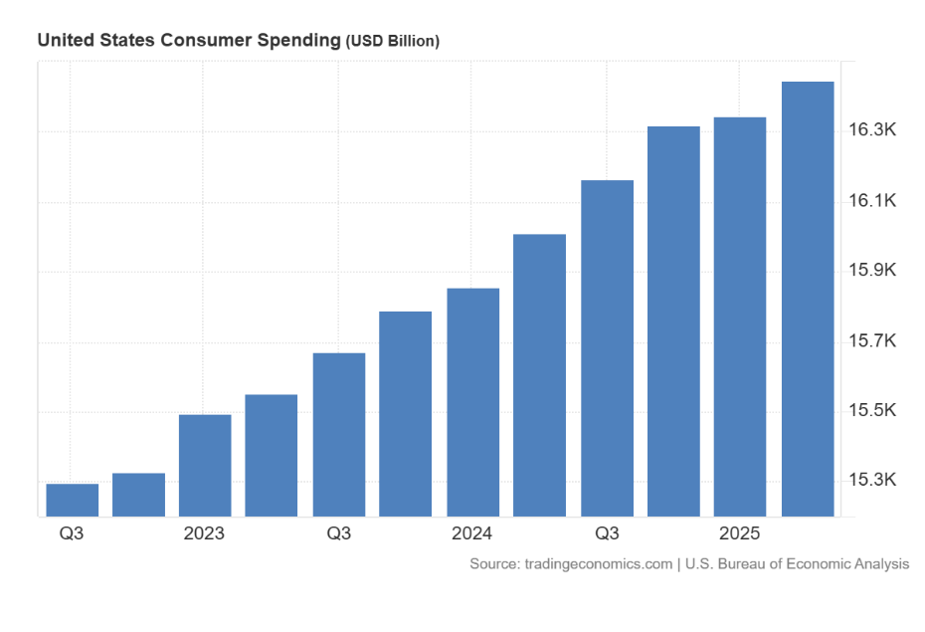
The US economy and the American consumer continue to surpass expectations. GDP remains on track for roughly 2% annual growth, driven higher by a massive investment cycle in AI data centers. Consumers are cautious but continue to spend albeit more selectively. The broader economy has yet to really pull out of the doldrums, but the new tax incentives from the Big Beautiful Bill should spur a wave of new investment in the US by early next year. Tariff uncertainty seems predominantly behind us, and hopefully that will give business leaders more confidence to invest in both their plants and their workers. The weakness in the overall job market, especially the hiring of new employees, may have been a consequence of this uncertainty and is hopefully behind us.

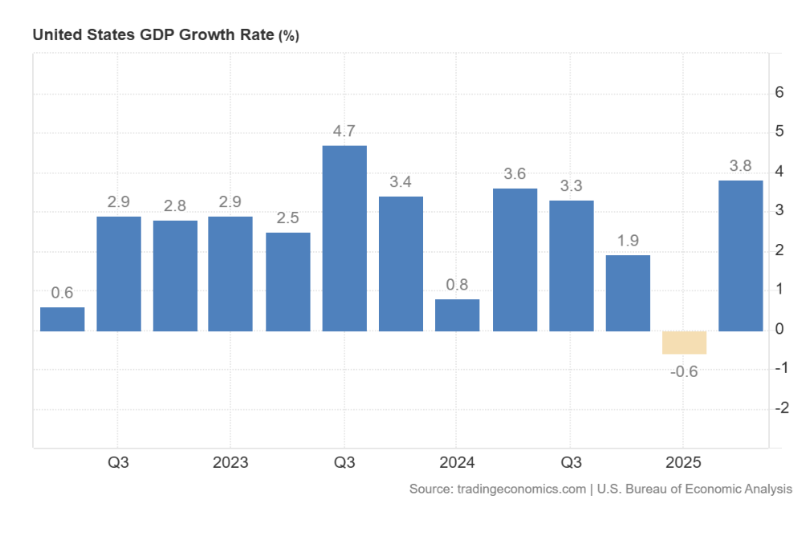
Now that the Fed has started a new rate cutting cycle, we would anticipate another one or two quarter point moves, with more likely in the first half of 2026. Unfortunately, we are not convinced that lower short-term rates will translate into similar moves in the long end of the treasury curve. With inflation sticky around 3% and deficits as high as they are, the 10-year rate is likely to stay around the 4% level which also means that mortgage rates may not change substantially.

The resumption of the Fed rate cut cycle has renewed enthusiasm for the more interest sensitive cyclical, but we view this part of the market with some caution. Concerns related to a potential growth slowdown could derail these parts of the market, and despite their strong performance we still prefer secular growth in AI-related Tech and Communication Services companies. The resurgence in mergers & acquisitions, as well as a revival in the IPO market will benefit financial sector companies with exposure to these capital markets. We also remain constructive on International Equities, as we expect that dollar weakness will continue for now. Keeping with that premise, we have selectively added exposure to Emerging Market stocks as well.

In our Fixed Income holdings, we remain focused on short to intermediate maturity bond funds. The additional yield from long-term bonds isn’t sufficient in our opinion to outweigh the risks from potentially higher rates. We also have limited exposure to credit risk via corporate bonds, as the spread between risk-free treasuries and corporate debt is near all-time low levels.

So, what’s our outlook as we come around the final turn and dash towards the finish line on the 2025 market race? Well, if we continue to have “a normal year” then the prospects heading into year-end look pretty good. Since 1950 the S&P 500 has returned 4.1% in the fourth quarter, often benefitting from a “Santa Clause” rally in December. While valuations are near historical highs, and some tariff uncertainties remain, we would expect the markets to finish the year on an optimistic note with the tailwinds from interest rate cuts by the Federal Reserve.

Regardless of whether we have a “normal” finish or not, I hope that you have a wonderful and enjoyable holiday season and I am grateful that you have entrusted the Pinnacle Consulting Group team to help you achieve your financial goals.

Don Garcia

Securities and investment advisory services are offered through the firms: Osaic Wealth, Inc. and Osaic Institutions, Inc., broker-dealers, registered investment advisers, and members of FINRA and SIPC. Securities are offered through Osaic Services, Inc. and Ladenburg Thalmann & Co., broker-dealers and members of FINRA and SIPC. Advisory services are offered through Ladenburg Thalmann Asset Management, Inc., and Osaic Advisory Services, LLC., registered investment advisers. Advisory programs offered by Osaic Wealth, Inc. are sponsored by VISION2020 Wealth Management Corp., an affiliated registered investment adviser.
See Osaic Wealth’s Form CRS Customer Relationship Summary, available here, for succinct information about the relationships and services Osaic Wealth offers to retail investors, related fees and costs,specified conflicts of interest, standards of conduct, and disciplinary history, among other things. Osaic Wealth’s Forms ADV, Part 2A, which describe Osaic Wealth’s investment advisory services, Regulation BestInterest Disclosure Document, which describes Osaic Wealth’s broker-dealer services, and other client disclosure documents can be found here.
CRN-6020501-101223
© Osaic, Inc. • osaic.com

